88mm FlaK
19
MILITARY

NONE
AIR POWER
N/A
RESOURCES
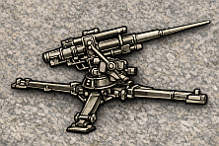
3 x FlaK 88mm Anti Tanks Units*
*Each marker can be immediately deployed to map or
Placed in Strategic Reserve box
ORDERS: 2 Actions

The 88 mm gun (eighty-eight) was a German anti-aircraft and anti-tank artillery gun from World War II. It was widely used by Germany throughout the war, and was one of the most recognizable German weapons of the war. Developments of the original models led to a wide variety of guns.Its success as an improvised anti-tank gun led to a separate line of guns for anti-tank use, the Panzerabwehr-Kanone (PaK) 88 (German: "anti-tank gun") and as the main armament for tanks such as the Tiger I.

